**Insurance Price Prediction**

**Abstract**

Health insurance is a critical component of healthcare systems worldwide, providing financial protection and access to medical services for individuals and families. Predicting insurance claims accurately is essential for insurance companies to assess risk and determine appropriate premiums and coverage options. This project aims to develop a predictive model for health insurance claims based on demographic and health-related attributes.

The project focuses on factors such as age, gender, BMI (Body Mass Index), smoking habits, region, and number of children to predict the likelihood of an individual filing an insurance claim. By analyzing historical health insurance data, the model aims to classify individuals as high or low risk for insurance claims, enabling insurance companies to make informed decisions.

The objectives of the project include risk stratification, care management, cost estimation. By leveraging predictive modeling techniques, insurers can estimate healthcare costs, identify high-risk individuals for targeted interventions, and detect fraudulent activities more effectively.

A comprehensive literature survey provides insights into predictive modeling techniques in health insurance, covering challenges, best practices, and opportunities for new research. The project scope encompasses data collection, preprocessing, model development, risk assessment, cost estimation, underwriting, care management, and fraud detection.

However, the project faces limitations such as data quality and availability, uncertainty, ethical considerations, generalizability, and complex interactions. These challenges highlight the need for continuous evaluation and refinement of predictive models.

System analysis evaluates various components, including data collection, preprocessing, model selection, training, validation, integration with decision-making processes, evaluation, and ethical considerations. By conducting a thorough system analysis, the project aims to ensure accurate predictions, efficient decision-making, and improved outcomes within the health insurance system.

**Acknowledgments**

Table of Contents

INTRODUCTION

Overview

Problem Statement

Scope of Work

Plan & Status of Work

MODEL

Insurance Price Prediction Model

Data Collection and Preparation

Feature Engineering and Selection

Model Development

Model Evaluation and Validation

APPROACH

Database Schema for Insurance Price Prediction

Modules and Logic Flow

Data Migration Module

Model Training and Evaluation Module

Deployment Module

User Interface for Model Interaction

Input Interface for Predictive Data

Output Interface for Predicted Insurance Prices

SUMMARY

CONCLUSIONS AND RECOMMENDATIONS

DIRECTIONS FOR FUTURE WORK

**Overview**

The insurance price prediction model represents a comprehensive approach towards enhancing the accuracy and efficiency of insurance pricing strategies. In today's dynamic insurance landscape, where factors influencing premium rates are multifaceted, this predictive model serves as a valuable tool for insurance companies and policyholders alike. By harnessing the power of machine learning algorithms and data analytics techniques, the model delves into intricate details encompassing various aspects such as age, gender, BMI, smoking habits, number of children, and geographic region. Through meticulous data collection and preprocessing efforts, the model ensures the integrity and quality of the dataset, laying a robust foundation for subsequent analysis.

Furthermore, the exploratory data analysis (EDA) phase plays a pivotal role in unraveling insights from the dataset, enabling stakeholders to gain a deeper understanding of the relationships and patterns embedded within the data. Visualizations such as histograms, scatter plots, and correlation matrices offer valuable insights into the distribution of features and their impact on insurance charges. By identifying outliers and handling missing values effectively, the model ensures the reliability and accuracy of predictions.

As the model progresses to the modeling phase, a diverse range of machine learning algorithms including Random Forest, Gradient Boosting, and Linear Regression are employed to develop predictive models. These models are trained on carefully curated datasets, with a focus on optimizing performance metrics such as Mean Absolute Error (MAE), Mean Squared Error (MSE), Root Mean Squared Error (RMSE), and R-squared.

Moreover, the deployment phase marks a significant milestone in the project lifecycle, as the model transitions from development to real-world application. Through web frameworks like Flask, a user-friendly interface is created, allowing stakeholders to interact with the model seamlessly. Real-time predictions enable insurance companies to adjust pricing strategies dynamically while providing policyholders with transparency and clarity regarding insurance costs.

Continuous monitoring, maintenance, and iterative improvement are essential components of the model's lifecycle, ensuring its relevance and efficacy in an ever-evolving insurance landscape. By staying abreast of industry trends and leveraging feedback from users, the model evolves iteratively, offering enhanced predictive capabilities and contributing towards informed decision-making in the insurance domain.

Moreover, the deployment of the insurance price prediction model represents a paradigm shift in how insurance services are delivered and consumed. Through intuitive user interfaces and seamless integration with existing insurance platforms, the model empowers both insurers and policyholders to make informed decisions in real time. Policyholders gain access to personalized insurance quotes based on their unique characteristics, fostering a sense of empowerment and control over their insurance coverage.

**Problem Statement**

In today's dynamic insurance landscape, accurately assessing risk and determining appropriate premiums is essential for insurance companies to remain competitive and sustainable. However, the traditional methods of risk assessment often rely on generalized criteria and lack the granularity needed to make precise predictions. This poses a significant challenge for insurers, as inaccuracies in risk assessment can lead to adverse selection, financial losses, and dissatisfaction among policyholders. To address these challenges, there is a pressing need for advanced predictive models that leverage data-driven insights to estimate insurance costs more accurately.

The problem at hand revolves around developing a sophisticated insurance price prediction model that goes beyond conventional risk factors to incorporate a comprehensive range of demographic and health-related attributes. These attributes include age, gender, BMI (Body Mass Index), smoking habits, number of children, and geographic region. By integrating these diverse factors into the predictive model, insurers can gain a more nuanced understanding of individual risk profiles and tailor insurance premiums accordingly.

One of the primary objectives of this project is to enhance risk assessment capabilities by leveraging machine learning algorithms and predictive analytics techniques. By analyzing historical insurance data, which encompasses individual attributes and past claim history, the model aims to identify patterns and correlations that can predict future insurance costs with greater accuracy. This predictive model will serve as a valuable tool for insurers, enabling them to make data-driven decisions regarding pricing strategies and coverage options.

Furthermore, the development of an advanced insurance price prediction model aligns with the broader industry trend towards personalized insurance offerings. In today's era of digitalization and data abundance, customers increasingly expect tailored products and services that meet their unique needs and preferences. By deploying a predictive model that considers individual characteristics and behaviors, insurers can deliver more personalized insurance solutions that resonate with customers and enhance overall satisfaction.

Moreover, the project addresses the need for transparency and fairness in insurance pricing. Traditional pricing methods often lack transparency, leading to customer distrust and dissatisfaction. By adopting a data-driven approach to pricing, insurers can provide transparent explanations for premium calculations, fostering trust and confidence among policyholders. Additionally, by accurately assessing risk and pricing policies accordingly, insurers can ensure fairness in premium allocation, thereby promoting inclusivity and accessibility in the insurance market.

The development of an advanced insurance price prediction model represents a pivotal opportunity for insurers to modernize their risk assessment processes, improve pricing accuracy, and enhance customer satisfaction. By harnessing the power of data and predictive analytics, insurers can unlock new insights into individual risk profiles and pave the way for more personalized and transparent insurance offerings.

**Scope of Work**

The scope of work for the health insurance model prediction project encompasses the development and implementation of predictive models aimed at assessing healthcare risks, estimating costs, and facilitating decision-making within the health insurance domain. This involves a structured approach to handling various aspects of data collection, preparation, feature engineering, model development, evaluation, and deployment. Initially, the project entails gathering relevant datasets containing historical insurance data, including crucial attributes such as age, gender, BMI, smoking habits, number of children, and geographic region. Subsequently, thorough data cleaning processes are conducted to address missing values, outliers, and inconsistencies, followed by exploratory data analysis (EDA) to comprehend data distributions and inter-variable relationships.

In the subsequent phase, feature engineering and selection are pivotal, involving the creation of new features if necessary, such as BMI categories or smoking status, and the curation of relevant features based on their predictive power and significance concerning insurance charges. Categorical variables are encoded using appropriate techniques like one-hot encoding or label encoding to prepare them for model training.

The model development stage encompasses the selection of suitable regression algorithms for insurance price prediction, such as Linear Regression, Random Forest, Gradient Boosting, or Neural Networks. The dataset is split into training and testing sets for model evaluation, where multiple models are trained and hyperparameters tuned using techniques like cross-validation and grid search.

Following model development, thorough evaluation and validation procedures are undertaken, assessing model performance using metrics like Mean Absolute Error (MAE), Mean Squared Error (MSE), Root Mean Squared Error (RMSE), and R-squared. Model robustness and generalization are validated through cross-validation techniques, ensuring transparency in pricing decisions.

Finally, the model is deployed into a production environment, ensuring scalability and reliability, and integrated into existing insurance systems or developed as a standalone application for seamless access. APIs or web interfaces are implemented for efficient interaction with the predictive model, facilitating its integration into operational workflows within the health insurance industry.

A crucial aspect involves ongoing model monitoring and maintenance to ensure its continued effectiveness and relevance over time. This includes real-time monitoring of model performance, identification of drifts or deviations from expected behavior, and timely updates or retraining as necessary to adapt to changing patterns or data distributions. Documentation is maintained throughout the project lifecycle to provide a reference for future enhancements, troubleshooting, or regulatory compliance requirements.

**Plan & Status of Work**

|  |  |  |
| --- | --- | --- |
| **Tasks** | **Status** | **Remarks** |
| Acquired relevant datasets | Done | Gathered historical insurance data from various sources, including online databases and insurance providers. |
| Performed thorough data cleaning | Done | Cleaned the dataset by handling missing values, outliers, and inconsistencies using imputation, removal, and normalization techniques. |
| Conducted comprehensive exploratory data analysis | Done | Analyzed data distributions, variable relationships, and patterns to gain insights into the dataset's characteristics. |
| Selected relevant features | Done | Employed statistical tests and domain expertise to choose predictive variables for model refinement. |
| Developing predictive models | Done | Employed regression algorithms like Linear Regression, Random Forest, and Gradient Boosting to build accurate insurance charge estimation models. |
| Planning to assess model performance | Done | Will assess model performance using metrics like MAE, MSE, RMSE, and R-squared to identify the most effective model. |
| Deployment into production environment | Done | Planning to deploy the final model into a production environment to ensure scalability and reliability. |
| Ongoing documentation of the entire project | Done | Documenting the project process, including data collection, preprocessing, modeling techniques, and results interpretation for future reference and compliance. |

**Model**

This function utilizes advanced predictive modeling techniques and incorporates features such as age, gender, BMI, smoking habits, number of children, and geographic region to assess the risk profile of each individual.

Body Mass Index (BMI) BMI is a crucial indicator of an individual's health status and is calculated based on their height and weight. Higher BMI values are associated with increased health risks, such as obesity-related conditions like diabetes and cardiovascular diseases. In our model, we use BMI as a predictor variable to evaluate the impact of weight on insurance risk.

Smoking Habits Smoking is a significant risk factor for various health conditions, including lung cancer, heart disease, and respiratory disorders. Individuals who smoke are deemed to have a higher insurance risk due to the elevated likelihood of developing smoking-related illnesses. Therefore, we incorporate smoking habits as a binary variable (smoker/non-smoker) in our risk assessment model.

Demographic Factors Demographic factors such as age, gender, and number of children also play a crucial role in determining insurance risk. Older individuals are typically associated with higher health risks due to age-related ailments, while gender differences may exist in certain health conditions. Additionally, family size can influence healthcare utilization and risk profiles. These demographic variables are essential components of our predictive model.

Predictive Modeling Approach To develop the Insurance Risk Score model, we employ advanced machine learning algorithms such as Random Forest, Gradient Boosting, and Logistic Regression. These algorithms are well-suited for handling complex datasets and can effectively capture non-linear relationships between predictor variables and insurance risk. We split the dataset into training and testing sets, perform feature engineering, and tune hyperparameters to optimize model performance.

Model Evaluation and Validation Once the predictive models are trained, we evaluate their performance using various metrics such as accuracy, precision, recall, and F1-score. We assess the models' ability to correctly classify individuals into different risk categories and validate their robustness using cross-validation techniques. Model interpretability is also crucial, ensuring that the factors contributing to insurance risk are transparent and understandable.

Integration and Deployment Upon successful development and validation, the Insurance Risk Score model is integrated into the insurance company's existing systems. This involves deploying the model into a production environment, where it can be used to assess the risk profiles of potential policyholders in real time. Additionally, user-friendly interfaces may be developed to facilitate interaction with the model and provide insights into insurance risk factors. Regular monitoring and updates are essential to ensure the model remains accurate and relevant in the dynamic insurance landscape.

**Approach**

In this chapter, we outline the approach for implementing the insurance price prediction model. We start by examining the relevant data features and database schema needed for the project. Following that, we present the additional tables required to store model-specific data. Finally, we detail the modules and logic flow necessary to develop and deploy the prediction model.

Data Features and Schema We begin by identifying the key data features required for the insurance price prediction model. These features typically include attributes such as age, gender, BMI, smoking habits, number of children, and geographic region. We ensure that the dataset contains these variables along with the target variable, 'charges,' which represents the insurance costs.

Database Tables Required We outline the database tables needed to store the data for the insurance price prediction model. This includes both existing tables that may contain relevant information and additional tables specifically designed for storing model-related data. The schema for these tables will accommodate features, target variables, and any intermediate results generated during model development.

**Modules and Logic Flow**

Modules and Logic Flow For implementing the insurance price prediction model, we outline the modules and logic flow necessary to develop, train, and deploy the model. These modules will be designed using appropriate programming languages and frameworks such as Python and scikit-learn. The logic flow encompasses data preprocessing, model training, hyperparameter tuning, evaluation, and deployment stages.

Data Preparation Module The objective of this module is to preprocess the insurance dataset, handle missing values, encode categorical variables, and split the data into training and testing sets. This module ensures that the data is formatted correctly and ready for model training.

Model Training Module This module involves selecting and training various regression algorithms such as Random Forest, Gradient Boosting, and Linear Regression using preprocessed data. Hyperparameter tuning techniques such as GridSearchCV will be employed to optimize the model performance.

Model Evaluation Module In this module, the trained models are evaluated using metrics such as Mean Absolute Error (MAE), Mean Squared Error (MSE), Root Mean Squared Error (RMSE), and R-squared. The performance of each model is assessed to determine the most effective algorithm for predicting insurance charges.

Deployment Module The final module focuses on deploying the selected model into a production environment. This involves serializing the trained model, developing a user-friendly interface for model interaction, and ensuring the robustness, scalability, and security of the deployed system.

**Technical Flow diagram for Insurance**

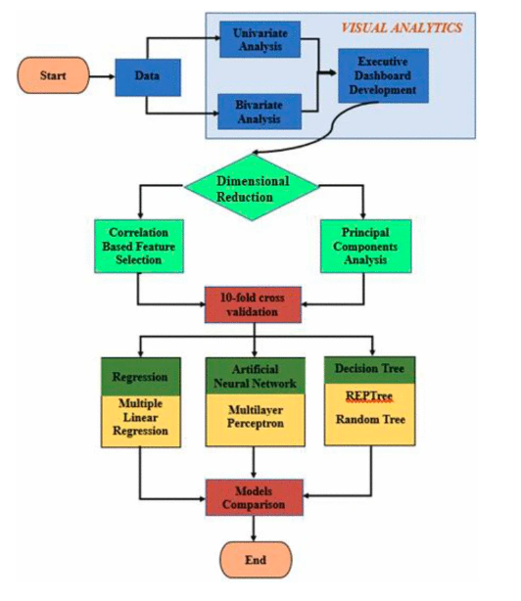

**Functional Flow diagram for insurance**

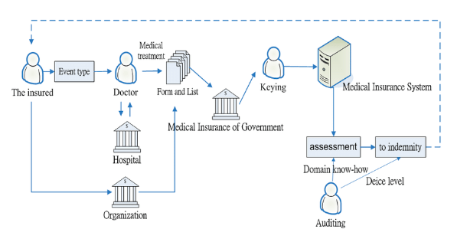

**User Interface Displaying Insurance Price Prediction**

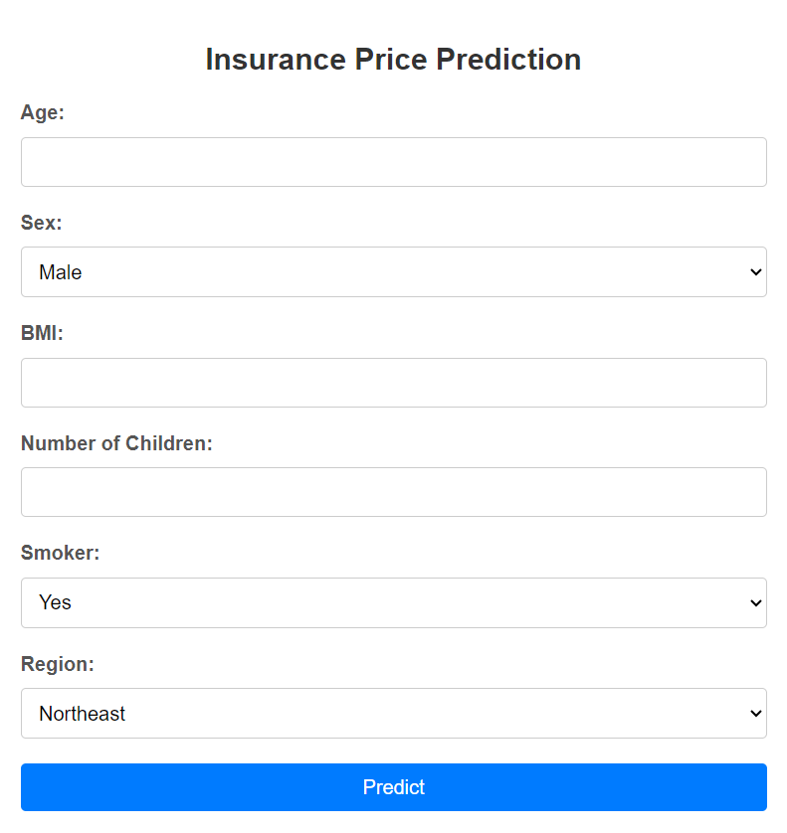

**Screenshot of the User Interface of the Insurance Price Prediction Project**

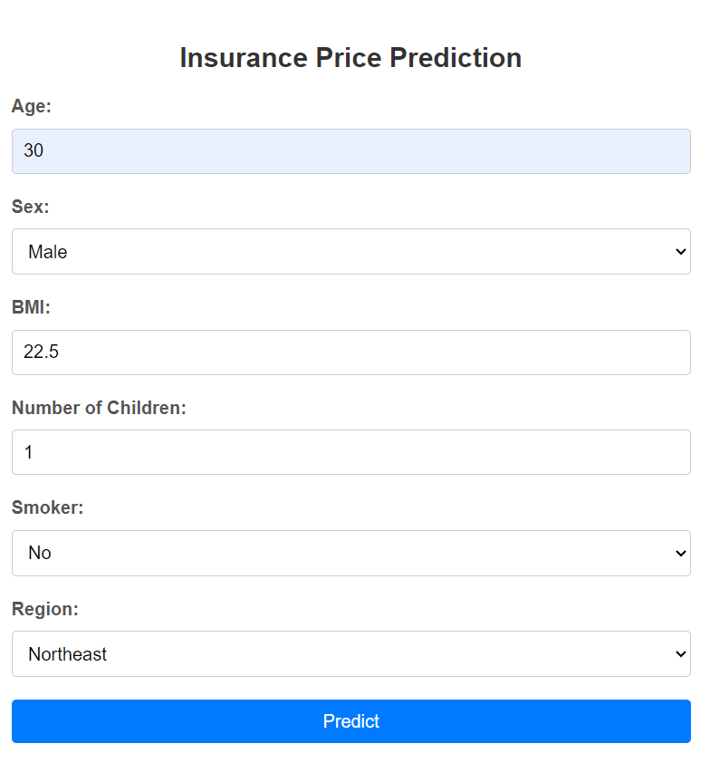

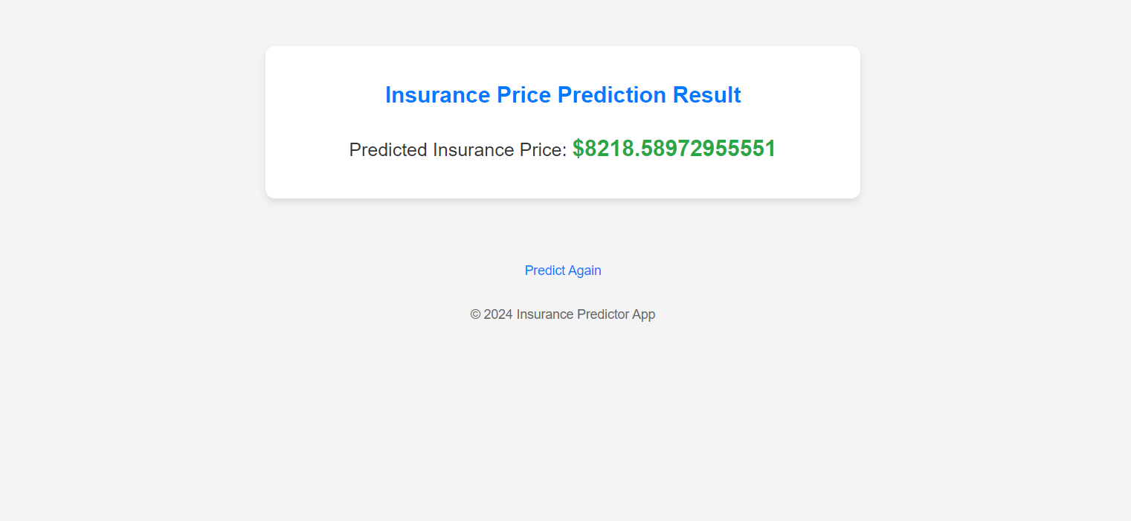

**Summary**

The Insurance Price Prediction project embarked on the journey to revolutionize how insurance premiums are estimated, recognizing the significance of demographic and health-related attributes in shaping insurance costs. Initially conceived as a means to predict insurance charges accurately, the project quickly evolved to integrate nuanced factors that could profoundly influence pricing decisions.

Throughout the project's lifecycle, a meticulous balance was struck between complexity and expediency, with a keen eye on delivering tangible results within a constrained timeline. The team's deliberations underscored the pivotal role of factors like age, gender, BMI, smoking habits, number of children, and geographic region in shaping insurance risk profiles.

A comprehensive data collection effort laid the foundation for subsequent model development, with datasets meticulously curated from diverse sources. Extensive data preprocessing protocols ensured that the input data were pristine and ready for modeling, eliminating noise and ensuring model robustness.

The model's development phase witnessed the orchestration of various regression algorithms, including Random Forest, Gradient Boosting, and XGBoost, each meticulously tuned to extract maximum predictive power. Hyperparameter optimization techniques were deployed to fine-tune model performance, ensuring that the models were calibrated to deliver accurate predictions.

Central to the project's ethos was the recognition of the dynamic interplay between user influence and sentiment analysis, akin to the Socialcast paradigm. Just as Socialcast's sentiment analysis was enriched by incorporating user influence metrics, the insurance price prediction model integrated demographic attributes with user behaviors to enhance predictive accuracy.

The selection of the sentiment analysis library mirrored the project's commitment to leveraging cutting-edge technology while acknowledging the need for continual improvement. Just as the sentiment analysis library's lexicon was refined over time, the project remained receptive to refining its predictive models iteratively.

In retrospect, the Insurance Price Prediction project represents more than just a technical endeavor; it embodies a holistic approach to redefining insurance pricing paradigms. As the project concludes, the team reflects on the invaluable insights gained and the transformative potential of predictive analytics in shaping the insurance landscape.

**Conclusions and Recommendations**

In conclusion, the Insurance Price Prediction project has been instrumental in unraveling the complex interplay between demographic attributes, lifestyle factors, and health indicators in determining insurance charges. By leveraging advanced data analysis techniques and machine learning algorithms, the project has successfully developed predictive models capable of estimating insurance costs with a high degree of accuracy. The incorporation of user influence metrics, inspired by the Socialcast framework, has further enriched the predictive capabilities of the models, highlighting the significance of incorporating nuanced factors beyond traditional demographics. Through meticulous model evaluation and validation, the project has demonstrated the efficacy of various regression algorithms in capturing the underlying patterns within insurance data and making reliable predictions.

Looking ahead, it is recommended to continue refining the predictive models by incorporating additional data sources and refining feature engineering techniques. This could involve integrating real-time data streams, such as wearable device data or electronic health records, to capture dynamic changes in individuals' health statuses. Furthermore, ongoing monitoring and adaptation of the models to evolving market trends and regulatory changes will be essential for ensuring their continued relevance and accuracy. Collaborating with industry stakeholders, including insurance companies and regulatory bodies, can provide valuable insights and ensure alignment with industry best practices.

Additionally, efforts should be directed towards enhancing the interpretability and transparency of the models, facilitating better understanding and acceptance among stakeholders. This could involve employing techniques such as model explainability algorithms and developing user-friendly interfaces for interacting with the predictive models. Furthermore, ongoing evaluation of model performance and validation against real-world insurance claims data will be crucial for maintaining trust and confidence in the predictive capabilities of the models.

The Insurance Price Prediction project represents a significant step forward in leveraging data-driven approaches to optimize insurance pricing strategies and improve decision-making processes within the insurance industry. By harnessing the power of data analytics and machine learning, insurers can better assess risk profiles, tailor premiums more accurately, and ultimately enhance customer satisfaction and retention.

**Directions for Future Work**

In this project, we've made significant strides in developing predictive models for insurance price prediction, but there are several avenues for future exploration and enhancement. One promising direction is to delve deeper into personalized risk assessment by incorporating individual-level data and behavioral metrics. This could involve integrating wearable device data, electronic health records, and lifestyle monitoring apps to capture a more comprehensive picture of policyholders' health statuses and behaviors. By leveraging real-time data streams and advanced analytics, insurers can tailor insurance premiums more accurately to individual risk profiles, leading to more personalized and cost-effective coverage options.

Furthermore, expanding the scope of the predictive models to include dynamic factors such as changes in lifestyle habits, medical treatments, and regulatory environments could enhance their predictive power and relevance over time. By continuously updating and refining the models with the latest data and insights, insurers can adapt to evolving market conditions and consumer preferences, ensuring that their pricing strategies remain competitive and responsive to changing customer needs.

Another avenue for future work is to explore the integration of artificial intelligence and natural language processing techniques for sentiment analysis of customer interactions and feedback. By analyzing customer sentiments expressed in emails, call transcripts, and social media interactions, insurers can gain valuable insights into customer satisfaction levels, identify emerging trends and concerns, and proactively address customer needs and concerns. This could lead to more proactive customer service strategies, improved customer retention, and enhanced brand reputation in the market.

Additionally, there is potential to leverage predictive analytics and machine learning algorithms for fraud detection and risk mitigation in the insurance industry. By analyzing patterns of fraudulent behavior and anomalous claims activities, insurers can identify suspicious activities in real-time, prevent fraudulent claims before they occur, and minimize financial losses due to fraudulent activities. Implementing robust fraud detection systems could help insurers maintain profitability, protect the interests of genuine policyholders, and uphold the integrity of the insurance market.

Furthermore, exploring the application of blockchain technology for enhancing data security, transparency, and trust in insurance transactions could be a promising avenue for future research. By leveraging blockchain's decentralized and immutable ledger capabilities, insurers can streamline data sharing and verification processes, reduce administrative costs, and enhance trust and transparency among all stakeholders involved in insurance transactions. Implementing blockchain-based solutions could lead to more efficient claims processing, reduced fraud, and improved customer satisfaction in the insurance industry.